**Providing access to users for different enterprise applications**

**Adding Users/Groups into Enterprise Application**

To incorporate users into an application, follow these steps:

* Login to Microsoft Entra admin center](<https://entra.microsoft.com/> )
* Navigate to the Identity blade, select the enterprise application, and then look for the desired application.

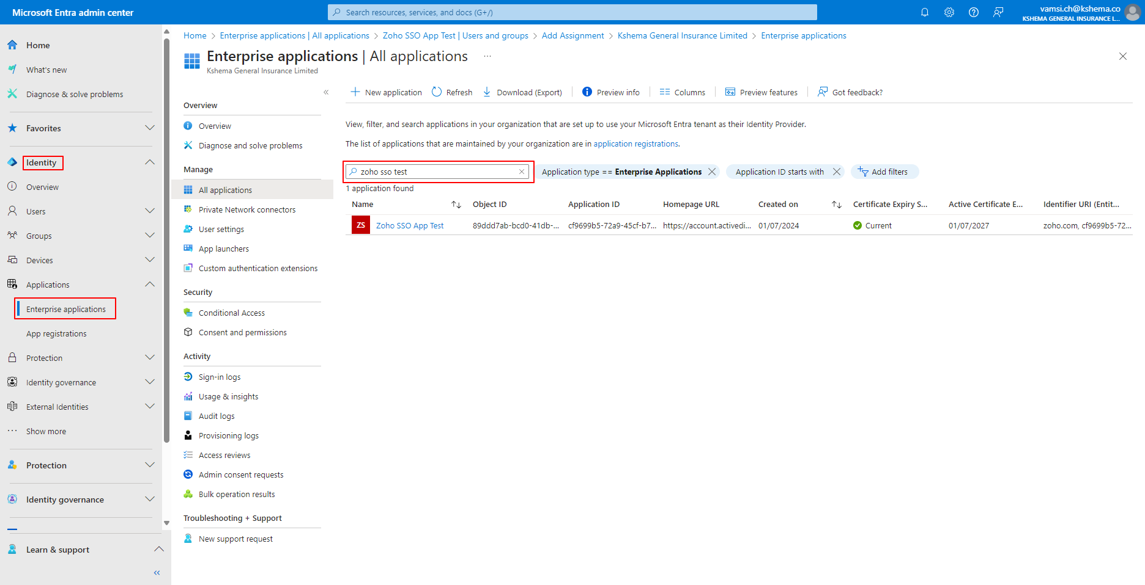

* Under the Manage section, select users and groups, then click on the add user/group option.

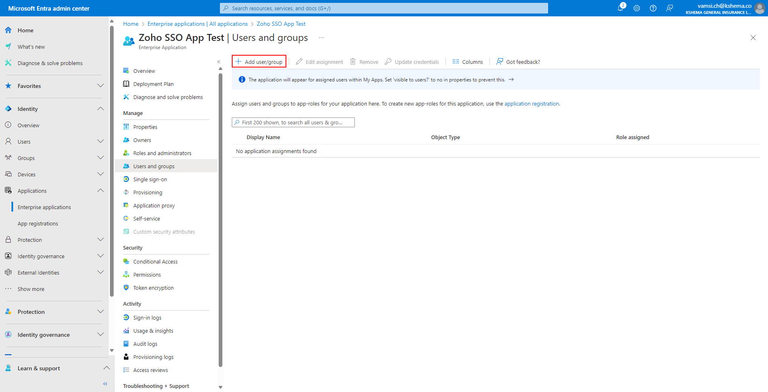

* Search for the desired group, select it, and in doing so, you can assign the group to access the application.

